**HACKATHON**

Take Home Programming

By Ajay Kumar Reddy Addula

St.Id: 16157735

# HACKATHON

## Objective

Hackathon is a web application which is used to create your own route, walk through a route that is available or through a route that someone created and trace the route. The User not only walk through the route but while walking he can also share the route, rate the route, pay some tips etc.

## Detail Design of service

**Architecture diagram**

In this Architecture diagram I explain in detail about the web application that I have created. It clearly explains about application and its navigation between page to page. This diagram also shows the database and the Web services that are used for the development of this application

Architecture Diagram



**Class diagram**

In this Class diagram we give a detail information about the application. It gives an explanation about the front and back end scenario. It gives relation between database and user. The route that is create will be stored in database as well as data base contain some route which can be used by the user.

Class Diagram



## fEATURES IMPLEMENTED

**wEBSERVICES**

In this project we used several web services and API's. The web services that we used are Google directions API web service, Google Location finder API web service, face book share and like API. Using this web services we create route, walk through the created route and save the created route. Can also share your starting and the ending location using the face book share API.

**DATABASE**

This database table is used to store the user information and allow him to login.

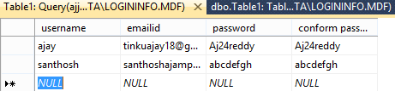

Created this database to store the created route but I couldn't do that.

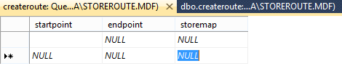

This is the existing Data model from Google

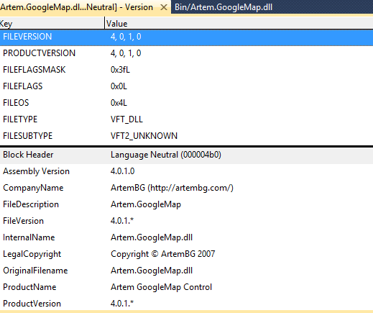

## Screen shots

Home page of my work which has three main buttons.

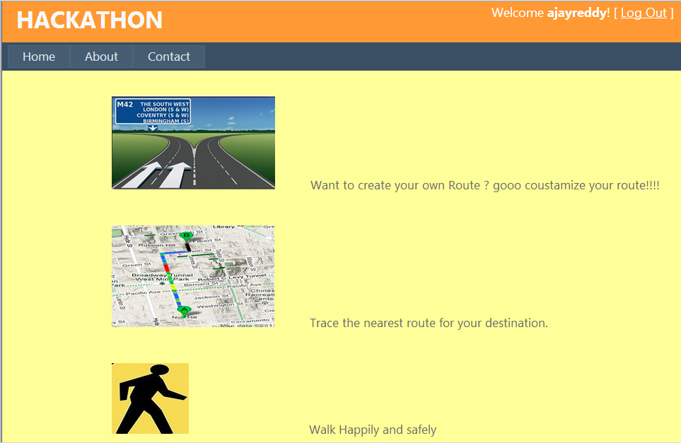

This is the Register page which shows error when incorrect password given :

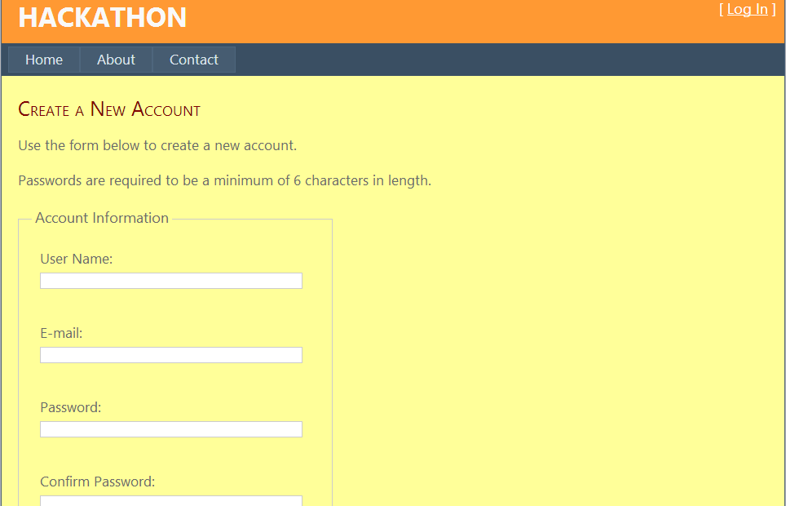

It is the login page :

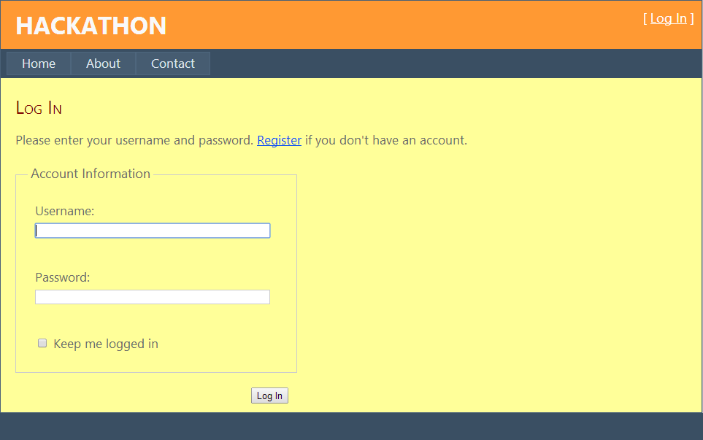

In this page we can find the directions between two places add some check points and then we need to create a route but I couldn't do that.

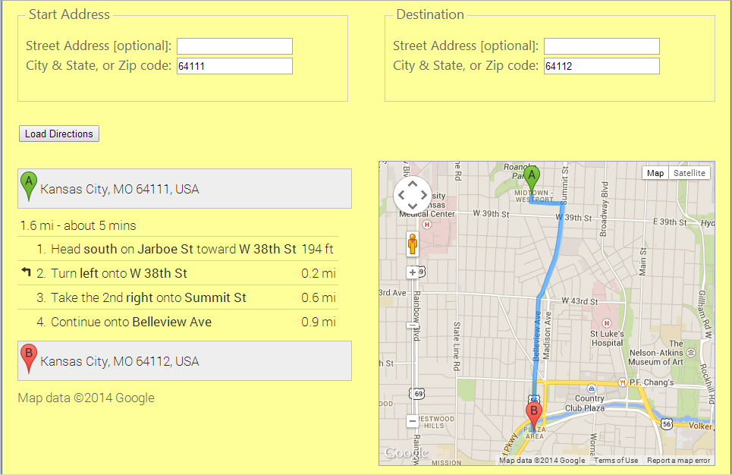

In this page we can share our start , end locations on Facebook.

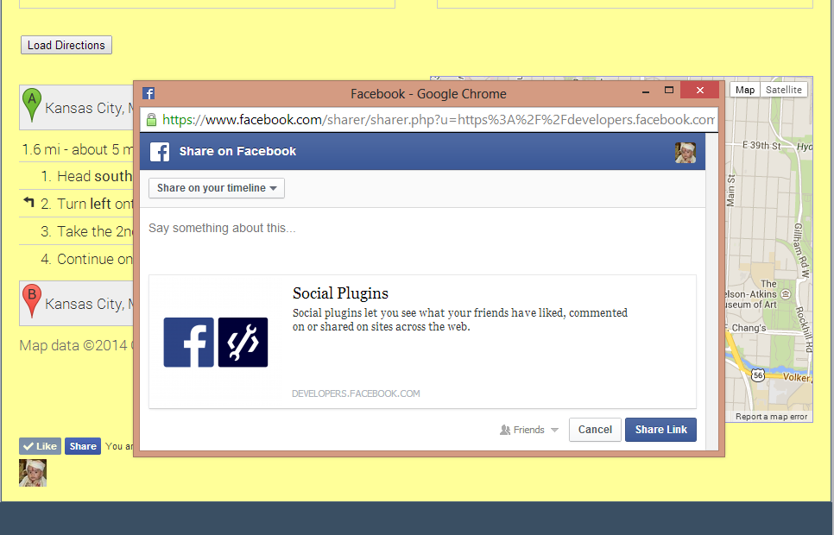

In this page we can trace the required locations.

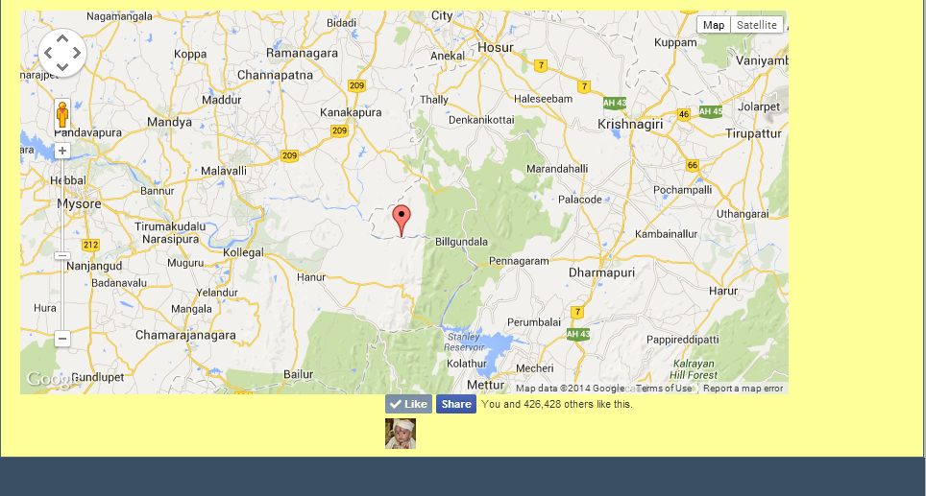

## limitations

Cannot save the created route in the local database.

Cannot add photos or description to the route.

## References

http://www.asp.net/

google directions api

google location finder api

https://developers.facebook.com/

http://www.haiders.net/post/GoogleMaps-Driving-Directions-API-Wrapper-Control-for-ASPNET.aspx